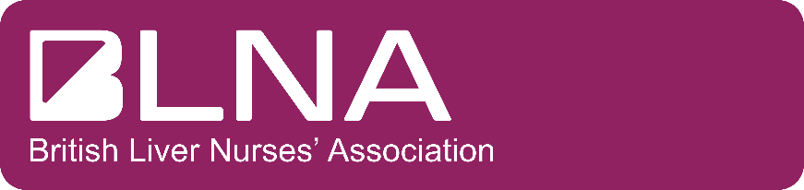

BLNA TRAVEL BURSARY SCHOLARSHIP 2022
Sponsored by Dr Falk Pharma and Intercept Pharma UK & Ireland

BLNA Annual Meeting 22nd & 23rd September
Queens Hotel, Leeds

Application Form
- Before completing the application form please refer to the Travel Bursary Scholarships Guidance Notes
- All sections of the application form must be completed or indicate with ‘not applicable’ where appropriate
- Please email a copy of the application form to: steve@basl.org.uk
- BLNA must receive your application by the deadline of 09.00hrs on Monday 1st August 2022
Employment Details
Name
Current Role
Department
Institution/Organisation
NMC / Professional body number
Telephone
Email
BASL/BLNA Membership No.

Previous Employment
Please list in Chronological order your past 7 years employment history
Years (from/to) | Job title | Institution/Organisation
Areas of Expertise and Interest
Please list your 3 main areas of expertise and interest
1)
2)
3)

Supporting Statement
Please tell us what your reasons are for wanting to attend the BLNA September Meeting 2022? (Min 150 words max 300 words)

Please discuss at least three areas within your practice that you feel attending the BLNA meeting will have an impact on?

Please tell us how you will share your learning with your team?

Signatures and Agreements
I have read the Travel Bursary Guidance Notes for the BLNA September meeting 2022 and agree to abide by the rules should my application be successful | YES/NO
I am a member of BASL / BLNA | YES/NO
I declare that the information I have provided on this form is accurate and true | YES/NO

Applicant’s Name | Signature (electronic not acceptable) | Date

