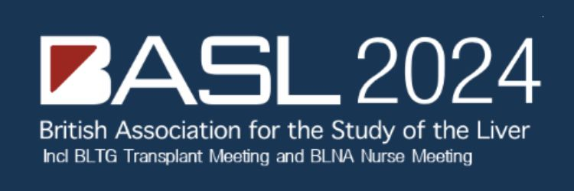

**EXHIBITION DURATION:**

BLTG: TUESDAY 8thOctober

ANNUAL MEETING: WEDNESDAY 9th – FRIDAY 11th October

|  |  |
| --- | --- |
| **Company:** |  |
| **Address:** |  |
|  |  |
|  |  |
|  |  |
| **Contact Name/s:** |  |
| **Tel No:** |  |
| **Email address/s:** |  |
|  |  |
| **Key Brand and Products to be Promoted:** |  |

**PACKAGE OPTIONS**

* Please Note: Some items are limited availability and will be offered on a first come first served basis.

Please indicate the items you would like to support:

|  |  |  |  |
| --- | --- | --- | --- |
| **PRIMARY SPONSORSHIPS** | **Notes** | **Cost (ex vat)** | **Please Select** |
| **GOLD PACKAGE (Max 5)  First Come First Served** | Includes exhibition space, industry symposium and complimentary places. Logo & profile on app | £28,000 |  |
| **SILVER PACKAGE** | Includes exhibition space and complimentary places. Logo & profile on app | £18,000 |  |
| **BRONZE PACKAGE** | Includes exhibition space and complimentary places. Logo & profile on app | £12,000 |  |
| **EXHIBITION** | | | |
| Exhibitor Package | See sponsorship prospectus | £3,500 |  |
| **ADDITIONAL STAND PERSONNEL @ £100 per person per day** | | | |
|  | |  | **Number** |
| Wednesday 9th October @ £100 per person | |  |  |
| Thursday 10th October @ £100 per person | |  |  |
| Friday 11th October @ £100 per person | |  |  |

**Stand personnel information – please complete**

|  |  |  |
| --- | --- | --- |
| **Full name** | **Email** | **Dietary requirements** |
|  |  |  |
|  |  |  |
|  |  |  |
|  |  |  |
|  |  |  |

|  |  |  |  |  |
| --- | --- | --- | --- | --- |
| **Tues 8th (BLTG)** | **Wed 9th** | **Thurs 10th** | **Fri 11th** | **Gala Dinner £60 +VAT pp** |
|  |  |  |  |  |
|  |  |  |  |  |
|  |  |  |  |  |
|  |  |  |  |  |
|  |  |  |  |  |

|  |  |  |  |
| --- | --- | --- | --- |
| **OTHER OPPORTUNITIES** | | | |
| Logo on Annual Meeting Name Badges * | Sponsor will have their logo positioned on all delegates name badges | £1,000 |  |
| Logo on Annual Meeting Lanyards * | Attendees will receive the sponsors lanyard with their name badge during registration | £600 |  |
| Branding in Registration Area | Branding and literature in the registration area | £1,000 |  |
| Sponsorship of Poster Viewing Area* | Includes poster viewing social event on Wednesday evening | £2,000 |  |
| Rolling Banner Advert on the app | Promotional banner displayed on each page of the meeting app | £500 |  |
| **BLTG TRANSPLANT MEETING OPPORTUNITIES** | | | |
| Premier Dual Package * | See sponsorship prospectus | £12,000 |  |
| Premier Package * | See sponsorship prospectus | £9,000 |  |
| Exhibitor Package | See sponsorship prospectus | £2,500 |  |
| **OTHER OPPORTUNITIES** | | | |
| Rolling Banner Advert on the app | Promotional banner displayed on each page of the meeting app during the BLTG Meeting | £300 |  |
| **BLNA MEETING OPPORTUNITIES** | | | |
| BLNA Sponsorship | See sponsorship prospectus | £5,500 |  |
| BLNA Exhibitor Package | See sponsorship prospectus | £3,500 |  |
| **OTHER OPPORTUNITIES** | | | |
| Bursaries | 10 bursaries @ £250 each | £2,500 |  |
| Logo on BLNA Name Badges * | Sponsor will have their logo positioned on all delegates name badges for BLNA Meeting | £200 |  |
| Logo on BLNA Lanyards * | Attendees will receive the sponsors lanyard for BLNA Meeting with their name badge | £200 |  |
| Rolling Banner Advert on the app | Promotional banner displayed on each page of the meeting app during the BLNA Meeting | £250 |  |
| **BESPOKE OPPORTUNITIES** | | | |
| Bespoke Packages (All meetings) | Email request to [conference@basl.org.uk](mailto:conference@basl.org.uk) | PoA |  |
|  |  |  |  |
| BASL Office Use Only | Total |  |  |

## PAYMENT DETAILS

|  |
| --- |
| **A deposit of 60% is due with your completed agreement form.**  **The remaining balance is due 120 days before the Event**.  Cancellations more than 120 days prior to the Event will be subject to a 25% administration charge. BASL reserve the right to apply the 100% cancellation charge and to resell the space within 120 days of the event. |

|  |  |
| --- | --- |
| I would like to pay by BACS and require an invoice. PO Number: |  |
| I enclose a cheque made payable to “British Association for the Study of the Liver” for | £ |



By signing the agreement form you are accepting the enclosed Exhibitor Terms and Conditions.

|  |  |  |  |
| --- | --- | --- | --- |
| Signed: |  | Date: |  |

**Please return completed form to:**

British Association for the Study of the Liver

BASL Secretariat Office c/o Executive Business Support Ltd

City Wharf, Davidson House, Lichfield, Staffordshire WS14 9DZ

[conference@basl.org.uk](mailto:steve@basl.org.uk) / [www.basl.org.uk](http://www.basl.org.uk) Tel: 01543 442154