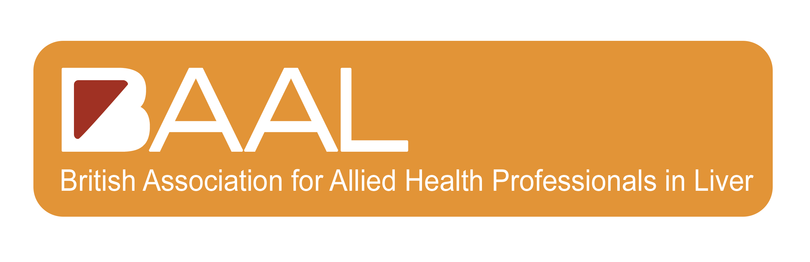

BASL/BLNA TRAVEL BURSARY SCHOLARSHIP 2023

BASL/BLNA Annual Meeting 21st & 22nd September
Double Tree Hilton Brighton

Application Form
- Before completing the application form please refer to the Travel Bursary Scholarships Guidance Notes
- All sections of the application form must be completed or indicate with ‘not applicable’ where appropriate
- Please email a copy of the application form to: conference@basl.org.uk
- BASL/BLNA must receive your application by the deadline of 17.00hrs on Friday 25th August 2023
Employment Details
Name
Current Role
Department
Institution/Organisation
NMC / Professional body number (if applicable)
Telephone
Email
BASL/BLNA Membership No.
Have you been awarded a travel bursary before to attend the BASL/BLNA September Annual Meeting? | YES / NO
If your answer to the above question is yes, in what year was the travel bursary
awarded (if known)?

Previous Employment
Please list in Chronological order your past 7 years employment history
Years (from/to) | Job title | Institution/Organisation

Areas of Expertise and Interest
Please list your 3 main areas of expertise and interest
1)
2)
3)

Supporting Statement
Please tell us what your reasons are for wanting to attend the BASL/BLNA September Meeting 2023? (Min 150 words max 300 words)

Please discuss at least three areas within your practice that you feel attending the BASL/BLNA meeting will have an impact on?

Please tell us how you will share your learning with your team?

Signatures and Agreements
I have read the Travel Bursary Guidance Notes for the BASL/BLNA September meeting 2023 and agree to abide by the rules should my application be successful | YES/NO
I am a member of BASL / BLNA | YES/NO
I declare that the information I have provided on this form is accurate and true | YES/NO

Applicant’s Name | Signature (electronic not acceptable) | Date

